Project Information
Client Name | Self-directed portfolio project — Kids' Language Learning
Curriculum title | Fun German for Kids
Course Title | Learn German Numbers 1–10

Versions
Date | Member Name | Role | Version | Affected Pages | Comment
29/08/2026 | Mohamed Sherif | E-learning developer | 1.0 | All | Initial full draft — kids' number cards, sing-along review, and quiz
07/10/2026 | Mohamed Sherif | E-learning developer | 2.0 | Screens 02–09, All | Storyboard updated to match Storyline: name entry and greeting split into two screens, progress indicator added, buttons in German, and the quiz cut to two interactive activities with a new score screen.

ID Name | DEK_S01_Welcome
Screen Type | Static — Title Screen
Screen Template | Title Screen Template (Kids)
Screen Number | 01
Chapter Title | Learn German Numbers 1–10
Lesson Title | Lesson 1 — Introduction
Topic Title | Welcome (Lerne deutsche Zahlen!)
Screen
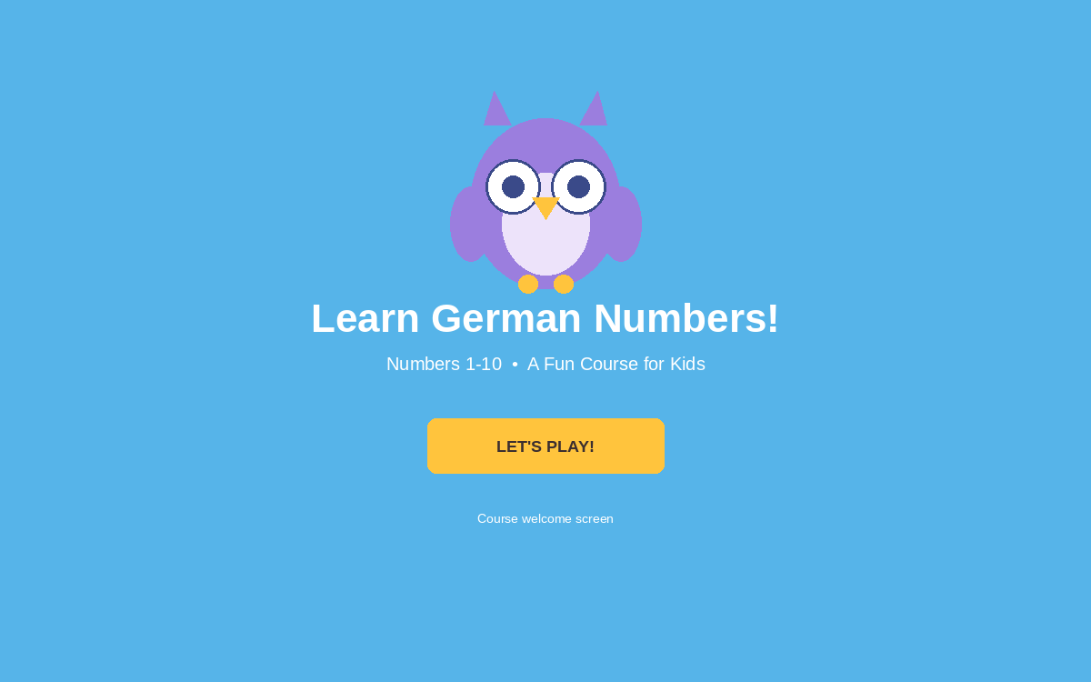
Item Naming | img_owlMascot, txt_courseTitle, txt_subtitle, btn_start, snd_introMusic
Graphic Description
  No | Graphic Description | No | Narration
  1 | Bright blue full-screen background with friendly owl mascot 'Otto', centered | 1 | Welcome, champion! Let's learn to count in German together!
  2 | Course title in bold white text: 'Lerne deutsche Zahlen!' (Learn German Numbers!) | 2 | We'll learn numbers from 1 to 10 together, and play fun games too!
  3 | Subtitle: 'Zahlen 1-10 • Ein unterhaltsamer Kurs für Kinder' | 3 | (Upbeat welcoming background music: start intro Music For kids course in number in german)
  4 | Big rounded CTA button: 'LASS UNS SPIELEN!' (Let's Play!) | 4 | Let's get started! Tap 'LASS UNS SPIELEN!' to begin!
Interaction instruction (prompt) | Tap "LASS UNS SPIELEN!" to begin.
Notes | Playful, rounded visual style with bright, high-contrast colors suited for young children (about ages 5–8). On-screen German title and start button: 'Lerne deutsche Zahlen!', 'LASS UNS SPIELEN!'. Audio background music plays on slide start. Tapping 'btn_start' navigates to Screen 02 (Name Entry).
Glossary | Lerne deutsche Zahlen! = Learn German Numbers! | Lass uns spielen! = Let's play!
Search Keywords | kids course, German numbers, language learning, title screen, welcome

ID Name | DEK_S02_NameEntry
Screen Type | Interactive — Text Entry / Onboarding
Screen Template | Text Entry Template (Kids)
Screen Number | 02
Chapter Title | Learn German Numbers 1–10
Lesson Title | Lesson 1 — Introduction
Topic Title | Wie heißen Sie? (What's Your Name?)
Screen
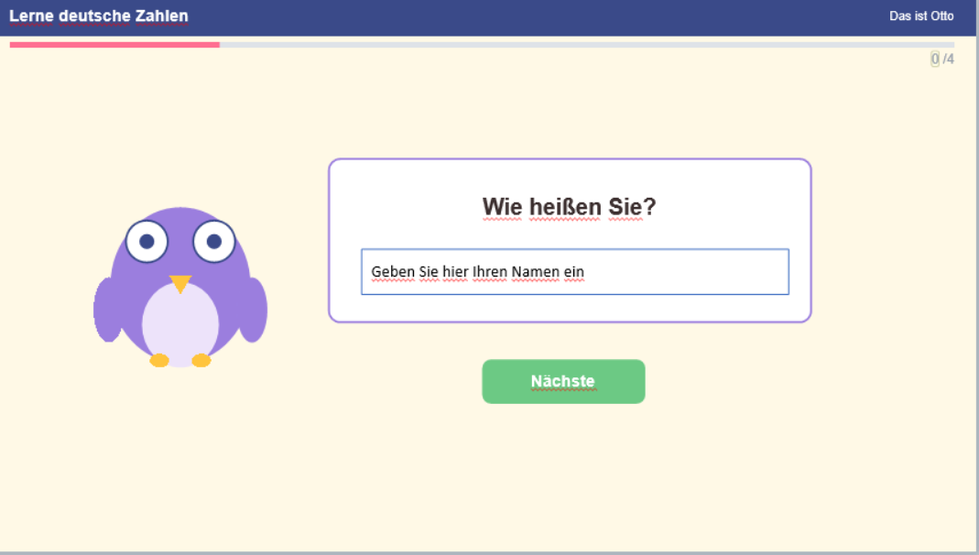
Item Naming | txt_header, txt_subHeader, txt_counter, img_owlMascot, txt_speechBubble, input_nameEntry, btn_next, var_Name, var_Count
Graphic Description
  No | Graphic Description | No | Narration
  1 | Top banner with course title 'Lerne deutsche Zahlen', topic 'Das ist Otto', and progress indicator '%Count% /4' (1/4) | 1 | Here's our friendly owl mascot 'Otto'—he wants to meet you!
  2 | Friendly owl mascot 'Otto' on the left with a speech bubble: 'Wie heißen Sie?' (What is your name?) | 2 | Otto asks in German: 'Wie heißen Sie?' That means: What is your name?
  3 | Interactive text entry field with placeholder: 'Geben Sie hier Ihren Namen ein' (Enter your name here), bound to variable %Name% | 3 | Type your name in the box so Otto can call you by your name!
  4 | Rounded navigation button on the bottom right: 'Nächste' (Next) | 4 | Once you enter your name, tap 'Nächste' to continue!
Interaction instruction (prompt) | Type your name in the text box and tap "Nächste".
Notes | Interactive name entry screen. Saves user input into variable %Name% for personalized interaction in the next slide. Progress indicator initialized at 1/4 (%Count%). Tapping 'Nächste' navigates to Screen 03.
Glossary | Wie heißen Sie? = What is your name? | Nächste = Next
Search Keywords | mascot, name entry, text entry, personalization, kids UX, onboarding

ID Name | DEK_S03_MeetOtto
Screen Type | Static / Dialogue — Personalized Mascot Introduction
Screen Template | Mascot Dialogue Template
Screen Number | 03
Chapter Title | Learn German Numbers 1–10
Lesson Title | Lesson 1 — Introduction
Topic Title | Meet Otto (Das ist Otto)
Screen
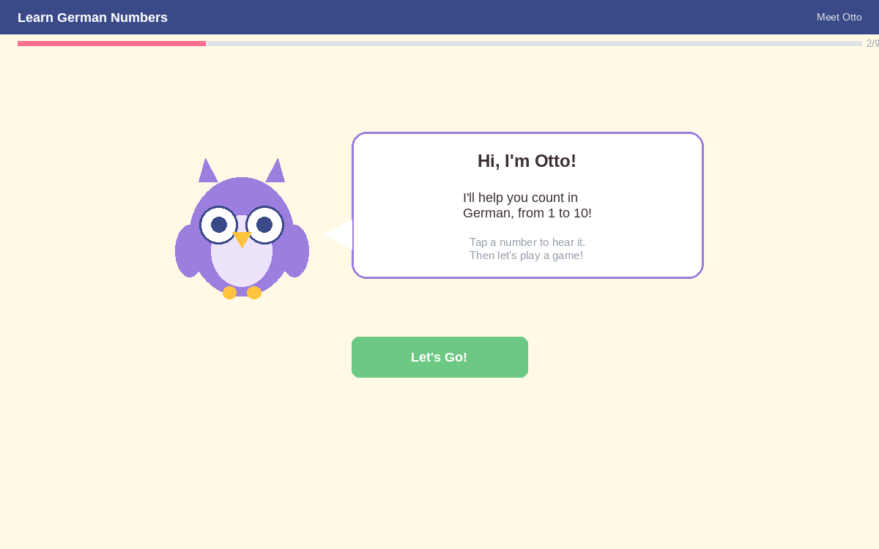
Item Naming | txt_header, txt_subHeader, txt_counter, img_owlMascot, txt_greeting, txt_desc1, txt_desc2, btn_letsGo, vo_ottoGreeting, var_Name
Graphic Description
  No | Graphic Description | No | Narration
  1 | Top banner: 'Lerne deutsche Zahlen' • 'Das ist Otto' with progress indicator '%Count% /4' | 1 | Otto is thrilled to meet you and welcomes you by name!
  2 | Owl mascot Otto waving with speech bubble personalized: 'Hallo %Name% , Ich bin Otto!' | 2 | Hello %Name%! I'm Otto, and I'll help you count in German from 1 to 10!
  3 | Dialogue text lines: 'Ich helfe dir beim Zählen auf Deutsch, von 1 bis 10!' and 'Tippe auf eine Zahl, um sie zu hören. Dann lass uns ein Spiel spielen!' | 3 | Tap any number to hear its German pronunciation, and then we'll play a fun game!
  4 | Big rounded CTA button: 'Lass uns gehen!' (Let's Go!) with friendly audio voiceover | 4 | Let's tap 'Lass uns gehen!' and start meeting the numbers!
Interaction instruction (prompt) | Tap "Lass uns gehen!" to start learning the numbers.
Notes | Personalized mascot introduction dynamically displaying %Name% in Otto's speech bubble ('Hallo %Name% , Ich bin Otto!'). Audio voiceover welcomes the child. Button 'Lass uns gehen!' navigates to Screen 04 (Numbers 1–5). Progress indicator: 1/4.
Glossary | Hallo = Hello | Lass uns gehen! = Let's go!
Search Keywords | mascot, character introduction, personalized greeting, Otto, kids UX

ID Name | DEK_S04_Numbers1to5
Screen Type | Interactive — Hotspot Number Cards
Screen Template | Number Card Grid Template
Screen Number | 04
Chapter Title | Learn German Numbers 1–10
Lesson Title | Lesson 2 — Numbers 1–5
Topic Title | Nummern 1–5
Screen
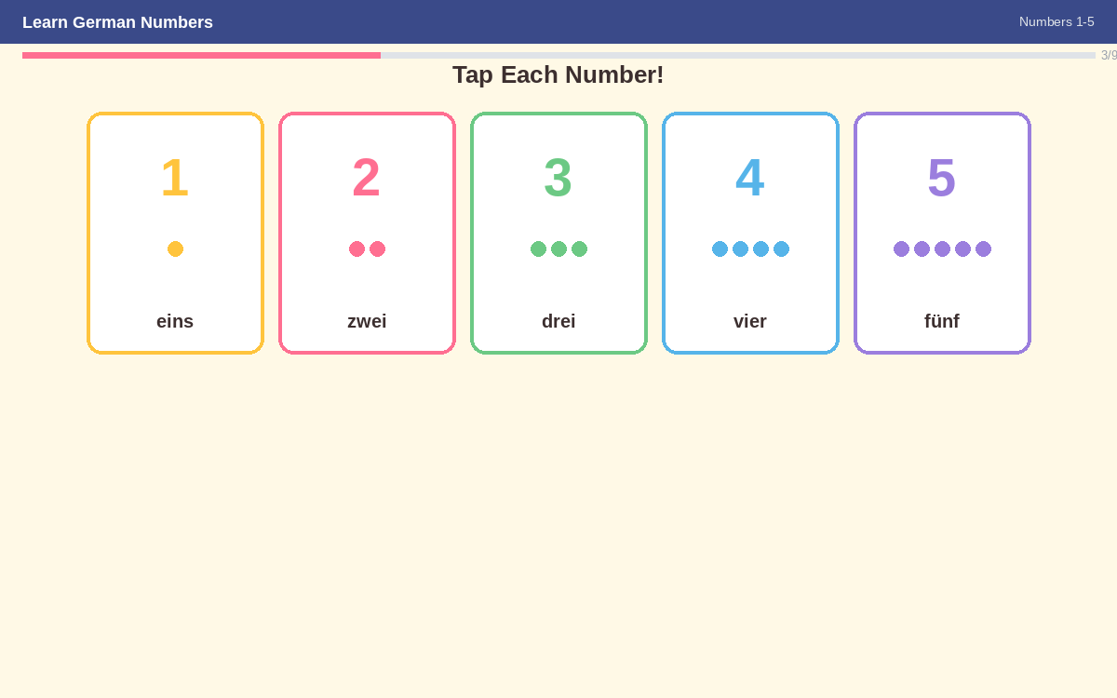
Item Naming | txt_header, txt_topicTitle, txt_counter, txt_instruction, card_1..card_5, vo_1..vo_5, btn_next, var_n1..var_n5, var_Count
Graphic Description
  No | Graphic Description | No | Narration
  1 | Top banner: 'Lerne deutsche Zahlen' • 'Nummern 1-5', progress indicator '%Count% /4' (2/4), and instruction: 'Tippe jede Zahl an!' | 1 | Tap each card to hear the number pronounced in German!
  2 | Card 1 — Large digit '1', German word 'eins' with audio voiceover | 2 | One in German: eins (pronounced: eyes-n / ayns).
  3 | Card 2 — Large digit '2', German word 'zwei' with audio voiceover | 3 | Two in German: zwei (pronounced: tsvye).
  4 | Card 3 — Large digit '3', German word 'drei' with audio voiceover | 4 | Three in German: drei (pronounced: dry).
  5 | Card 4 — Large digit '4', German word 'vier' with audio voiceover | 5 | Four in German: vier (pronounced: feer).
  6 | Card 5 — Large digit '5', German word 'fünf' with audio voiceover | 6 | Five in German: fünf (pronounced: foonf).
Interaction instruction (prompt) | Tippe jede Zahl an! (Tap each of the 5 cards to hear its German name. Then tap Next).
Notes | Interactive number exploration cards 1–5. Tapping each card triggers authentic native German pronunciation (TTS voiceovers). Variables n1..n5 track visited states. Progress indicator: 2/4. Navigation button advances to Screen 05.
Glossary | eins = 1 | zwei = 2 | drei = 3 | vier = 4 | fünf = 5 | Tippe jede Zahl an! = Tap every number!
Search Keywords | German numbers, counting 1-5, hotspot cards, audio pronunciation, kids interaction

ID Name | DEK_S05_Numbers6to10
Screen Type | Interactive — Hotspot Number Cards
Screen Template | Number Card Grid Template
Screen Number | 05
Chapter Title | Learn German Numbers 1–10
Lesson Title | Lesson 2 — Numbers 6–10
Topic Title | Nummern 6–10
Screen
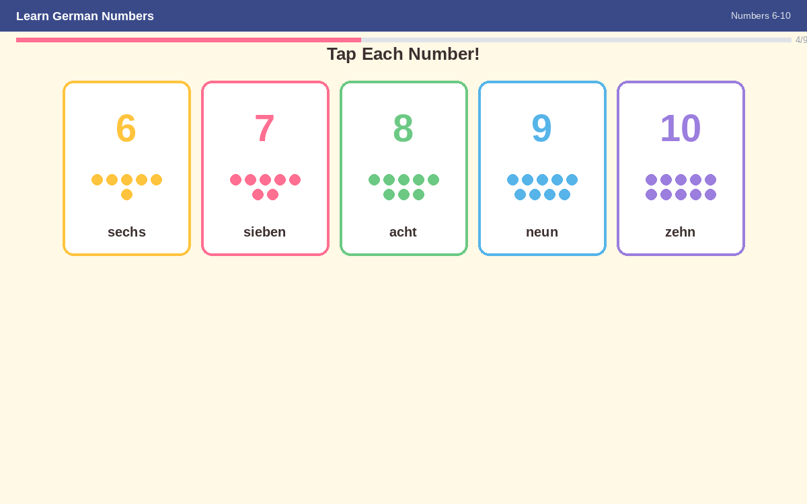
Item Naming | txt_header, txt_topicTitle, txt_counter, txt_instruction, card_6..card_10, vo_6..vo_10, btn_next, var_Count
Graphic Description
  No | Graphic Description | No | Narration
  1 | Top banner: 'Lerne deutsche Zahlen' • 'Nummern 6-10', progress indicator '%Count% /4' (3/4), and instruction: 'Tippe jede Zahl an!' | 1 | Now after the first five numbers, let's keep going from 6 to 10! Tap each card.
  2 | Card 6 — Large digit '6', German word 'sechs' with audio voiceover | 2 | Six in German: sechs (pronounced: zex).
  3 | Card 7 — Large digit '7', German word 'sieben' with audio voiceover | 3 | Seven in German: sieben (pronounced: zee-ben).
  4 | Card 8 — Large digit '8', German word 'acht' with audio voiceover | 4 | Eight in German: acht (pronounced: ahkt).
  5 | Card 9 — Large digit '9', German word 'neun' with audio voiceover | 5 | Nine in German: neun (pronounced: noyn).
  6 | Card 10 — Large digit '10', German word 'zehn' with audio voiceover | 6 | Ten in German: zehn (pronounced: tsayn).
Interaction instruction (prompt) | Tippe jede Zahl an! (Tap each of the 5 cards to hear its German name. Then tap Next).
Notes | Interactive number exploration cards 6–10. Each card plays its German pronunciation audio on click. Progress indicator: 3/4 (%Count%). Navigation button advances to Screen 06.
Glossary | sechs = 6 | sieben = 7 | acht = 8 | neun = 9 | zehn = 10
Search Keywords | German numbers, counting 6-10, hotspot cards, audio pronunciation, kids interaction

ID Name | DEK_S06_PracticeTogether
Screen Type | Static / Interactive — Review & Sing-Along
Screen Template | Review Grid Template
Screen Number | 06
Chapter Title | Learn German Numbers 1–10
Lesson Title | Lesson 3 — Let's Practice
Topic Title | Gemeinsam üben (Practice Together)
Screen
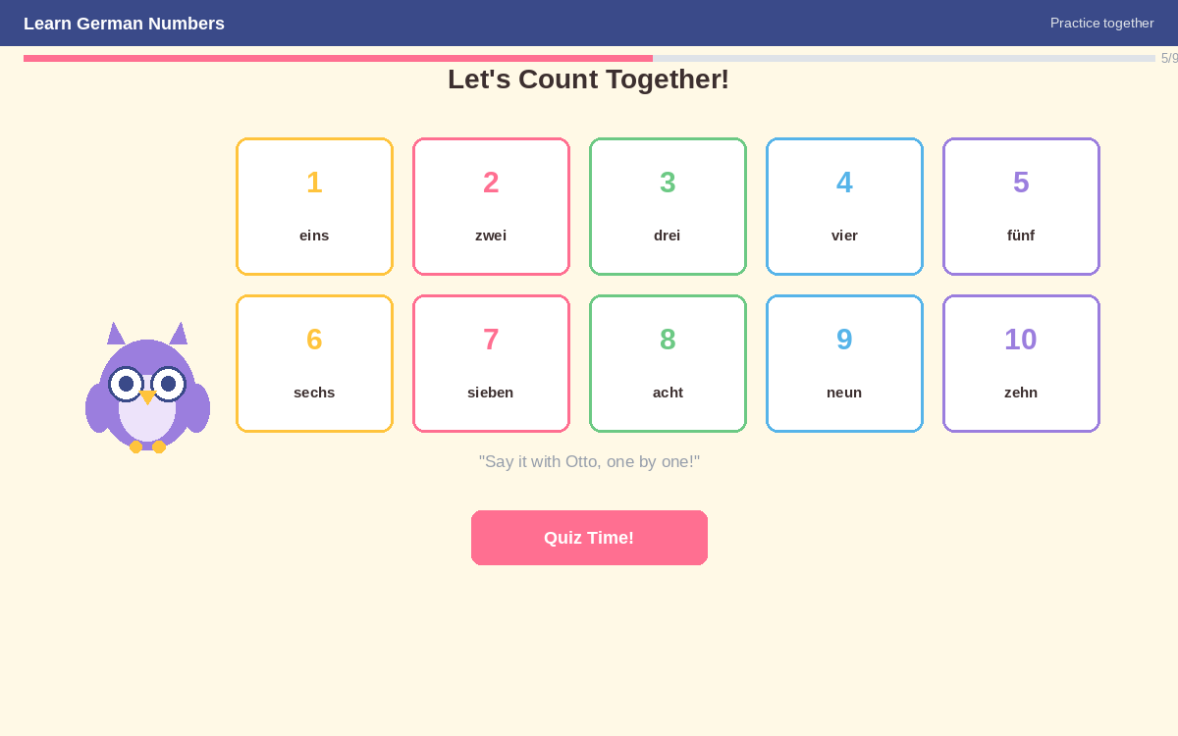
Item Naming | txt_header, txt_topicTitle, txt_counter, txt_instruction, grid_allNumbers_1to10, txt_ottoPrompt, snd_zahlenliedSong, vo_otto, btn_quizzeit, var_Count
Graphic Description
  No | Graphic Description | No | Narration
  1 | Top banner: 'Lerne deutsche Zahlen' • 'Gemeinsam üben', progress '%Count% /4' (4/4), and banner 'Lasst uns gemeinsam zählen!' | 1 | Let's count them all together from 1 to 10 out loud with a fun song!
  2 | Full 5x2 grid showing numbers 1–10 with digits and German words (1 eins, 2 zwei, 3 drei, 4 vier, 5 fünf, 6 sechs, 7 sieben, 8 acht, 9 neun, 10 zehn) | 2 | One (eins), two (zwei), three (drei)... all the way to ten (zehn)! Say it with Otto!
  3 | Otto prompt: 'Sprich es mit Otto, eins nach dem anderen!' with German Numbers Song audio ('Numbers Song in German. Zahlenlied') | 3 | (German numbers counting song 'Zahlenlied' plays to reinforce memory and rhythm)
  4 | Big CTA button: 'Quizzeit!' (Quiz Time!) | 4 | Ready to test your skills and play a game? Click 'Quizzeit!' and let's go!
Interaction instruction (prompt) | Say each number out loud with Otto, then tap "Quizzeit!".
Notes | Comprehensive review screen before the graded quiz. Plays German numbers sing-along song (Zahlenlied) with timed synchronization. Progress indicator: 4/4 (%Count%). Tapping 'Quizzeit!' branches to the Quiz Scene (Screen 07).
Glossary | Gemeinsam üben = Practice together | Lasst uns gemeinsam zählen! = Let's count together! | Quizzeit! = Quiz time!
Search Keywords | review, repetition, sing-along, reinforcement, Zahlenlied, German numbers 1-10

ID Name | DEK_S07_QuizQ1
Screen Type | Interactive — Graded Quiz (Freeform Pick One - Audio & Visual Counting)
Screen Template | Quiz Template (Kids Pick One)
Screen Number | 07
Chapter Title | Learn German Numbers 1–10
Lesson Title | Lesson 4 — Quiz Time
Topic Title | Quiz — Frage 1 von 2
Screen
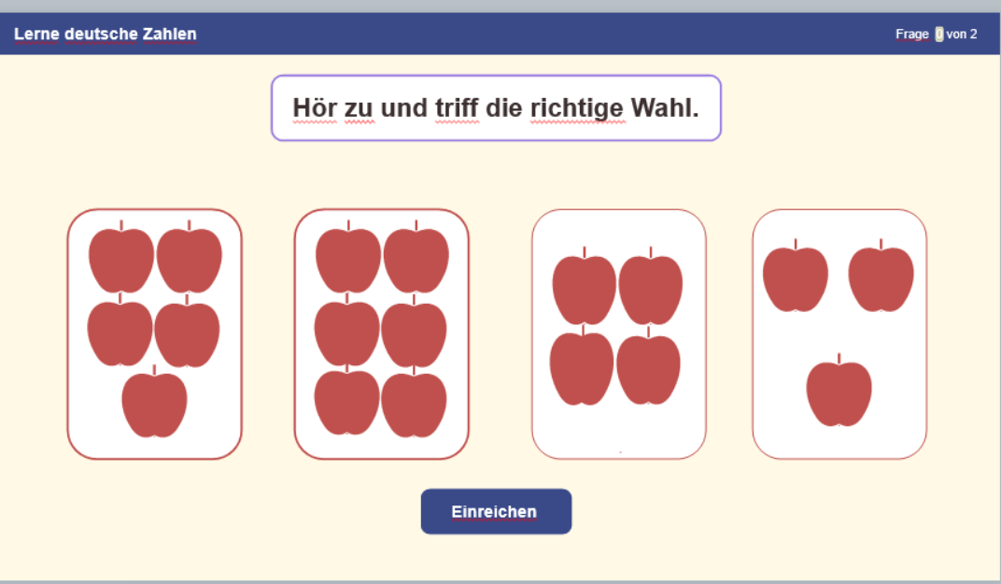
Item Naming | txt_header, txt_questionNumber, banner_instruction, vo_targetNumber, card_opt1_5apples, card_opt2_4apples, card_opt3_3apples, card_opt4_6apples, btn_submit, lyr_correct, lyr_incorrect, var_Count, Quiz1_ScorePoints
Graphic Description
  No | Graphic Description | No | Narration
  1 | Question banner: 'Lerne deutsche Zahlen' • 'Frage %Count% von 2' (1 of 2) with instruction: 'Hör zu und triff die richtige Wahl.' (Listen and make the right choice) | 1 | Listen closely to the number word, and choose the card that has that exact number of apples!
  2 | Voiceover audio plays German number word: 'fünf' (5) | 2 | (Voiceover clearly pronounces the German number word: 'fünf')
  3 | 4 interactive visual cards with illustrated apples: Card 1 (5 apples — Correct), Card 2 (4 apples), Card 3 (3 apples), Card 4 (6 apples) | 3 | Count the apples on each card and pick the card with 5 apples ('fünf').
  4 | Submit button: 'Einreichen' + Correct / Incorrect feedback layers with 'Continue' button | 4 | Once you select your card, click 'Einreichen' to submit your answer.
Interaction instruction (prompt) | Listen to the audio, count the apples, tap the correct card, and tap "Einreichen".
Notes | Freeform Pick One graded interaction. Voiceover pronounces 'fünf'. Correct answer is Card 1 (5 apples). Awarded points added to Quiz1.ScorePoints. Feedback layers provide immediate encouragement. Progress indicator: Frage 1 von 2.
Glossary | Frage 1 von 2 = Question 1 of 2 | Hör zu und triff die richtige Wahl = Listen and make the right choice | Einreichen = Submit
Search Keywords | quiz, listening comprehension, counting apples, pick one, audio question, German numbers

ID Name | DEK_S08_QuizQ2
Screen Type | Interactive — Graded Quiz (Drag and Drop Matching)
Screen Template | Quiz Template (Kids Drag & Drop)
Screen Number | 08
Chapter Title | Learn German Numbers 1–10
Lesson Title | Lesson 4 — Quiz Time
Topic Title | Quiz — Frage 2 von 2
Screen
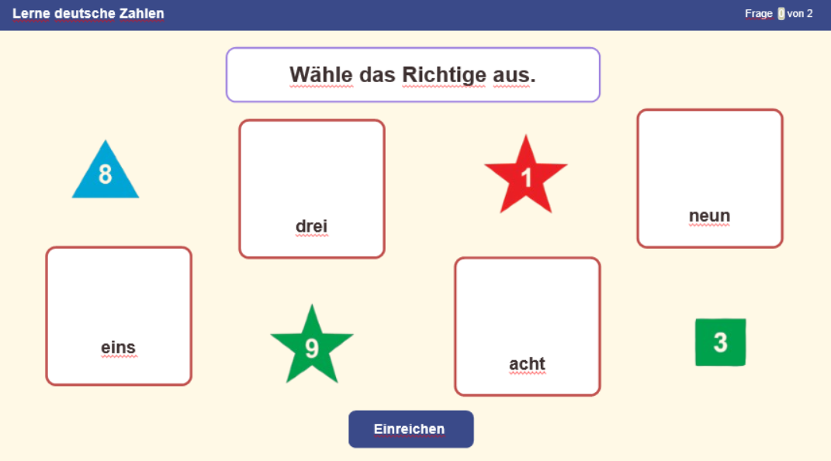
Item Naming | txt_header, txt_questionNumber, banner_instruction, drag_star1, drag_star9, drag_triangle8, drag_square3, drop_eins, drop_neun, drop_acht, drop_drei, btn_submit, lyr_correct, lyr_incorrect, Quiz1_ScorePoints
Graphic Description
  No | Graphic Description | No | Narration
  1 | Question banner: 'Lerne deutsche Zahlen' • 'Frage %Count% von 2' (2 of 2) with instruction: 'Wähle das Richtige aus.' (Match the shapes to the correct words) | 1 | Match each numbered shape to the correct written German word container!
  2 | 4 draggable geometric shapes: Red star '1' (audio 'eins'), Green star '9' (audio 'neun'), Blue triangle '8' (audio 'acht'), Green square '3' (audio 'drei') | 2 | Drag each of the 4 shapes. Whenever you tap or drag a shape, you'll hear its German pronunciation.
  3 | 4 drop targets labeled with German number words: 'eins', 'neun', 'acht', 'drei' | 3 | Drop 1 onto eins, 9 onto neun, 8 onto acht, and 3 onto drei.
  4 | Submit button: 'Einreichen' + Correct / Incorrect feedback layers with 'Continue' button | 4 | After placing all the shapes into their matching spots, click 'Einreichen'.
Interaction instruction (prompt) | Drag each numbered shape onto its matching German name, then tap "Einreichen".
Notes | Interactive Drag and Drop graded activity. Audio clips play pronunciation on drag/drop for multisensory learning. Correct pairings: 1 -> eins, 9 -> neun, 8 -> acht, 3 -> drei. Scoring recorded in Quiz1.ScorePoints. Navigation advances to Screen 09.
Glossary | Wähle das Richtige aus = Choose / match the correct answer | Einreichen = Submit
Search Keywords | quiz, drag and drop, shapes matching, eins, neun, acht, drei, interactive activity

ID Name | DEK_S09_Results
Screen Type | Static — Results / Celebration
Screen Template | Celebration Template
Screen Number | 09
Chapter Title | Learn German Numbers 1–10
Lesson Title | Lesson 4 — Quiz Time
Topic Title | Your Results (Ergebnis)
Screen
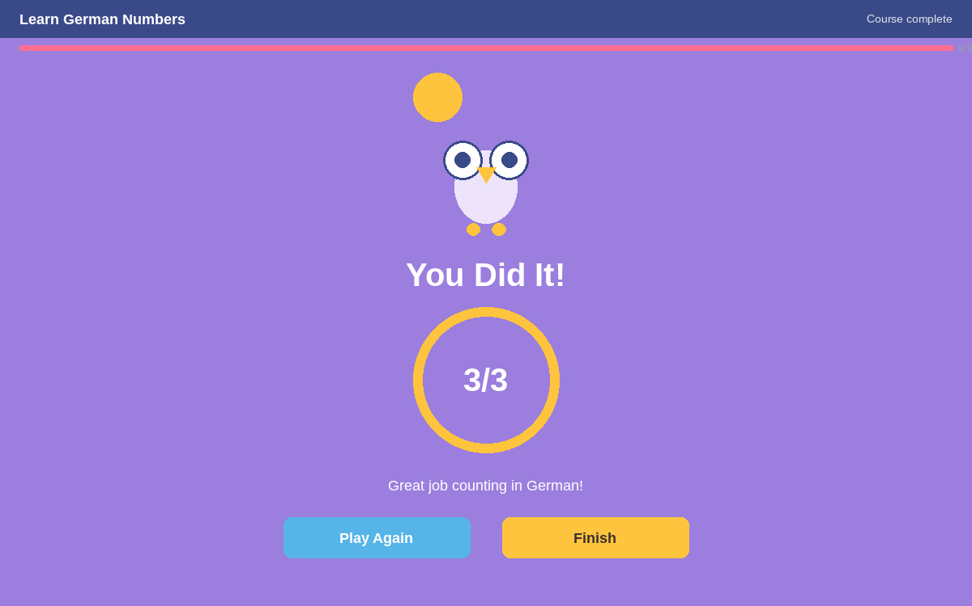
Item Naming | img_owlMascot, txt_celebrationTitle, txt_celebrationSubtitle, txt_scoreDisplay, btn_playAgain, btn_exit, var_Quiz1_ScorePoints
Graphic Description
  No | Graphic Description | No | Narration
  1 | Celebration screen with cheerful Otto the owl mascot with confetti and star sparkles. Title: 'Du hast es geschafft!' (You did it!) | 1 | Bravo, superstar! 🎉 Awesome job, you passed the challenge!
  2 | Score display box showing points scored: '%Quiz1.ScorePoints% Punkte' (Points) | 2 | You completed the course and quiz! Check out the points you earned.
  3 | Celebratory subtitle: 'Super, dass du auf Deutsch gezählt hast!' (Great that you counted in German!) | 3 | You can now count in German from 1 to 10 like a pro! Excellent!
  4 | Two navigation buttons: 'Erneut spielen' (Play Again) and 'Beenden' (Exit) | 4 | Want to play again? Click 'Erneut spielen', or click 'Beenden' to exit.
Interaction instruction (prompt) | Tap "Beenden" to finish the course, or "Erneut spielen" to try the quiz again.
Notes | Course completion and assessment summary. Displays score points via variable %Quiz1.ScorePoints% Punkte. 'Erneut spielen' jumps to the Quiz scene to retry. 'Beenden' executes the exitProject trigger and sends completion status to LMS. Last screen (9/9).
Glossary | Du hast es geschafft! = You did it! | Punkte = Points | Erneut spielen = Play again | Beenden = Exit
Search Keywords | celebration, results, completion, score points, Erneut spielen, Beenden

